Comp 310 HW 6 Jared Fowler

**Problem 1.** Create a TM which decides $\left\{a^{i}b^{j}c^{i}d^{j}\right\}.$

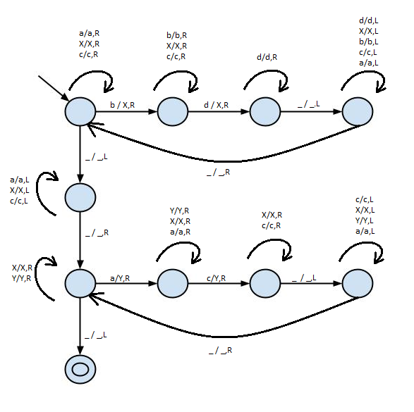

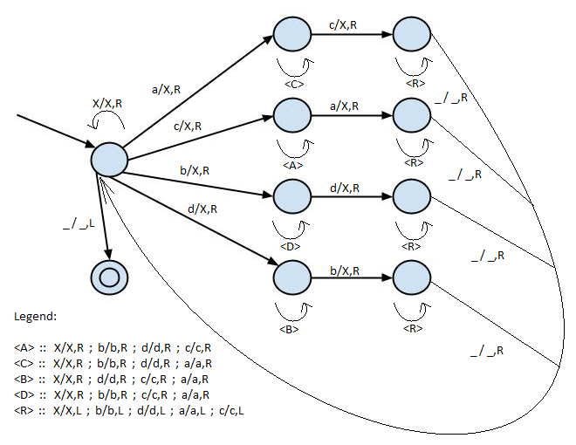**Problem 2.** Create a TM which decides $\left\{w ϵ {\left\{a,b,c,d\right\}}^{*} :n_{a}=n_{c} \&\& n_{b}=n_{d}\right\}.$

**Problem 3.** Create a TM transducer which begins with a strictly positive binary number on the tape and halts with the binary number which is one smaller on the tape.

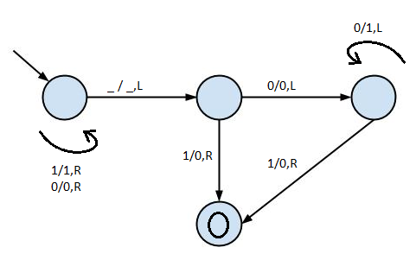

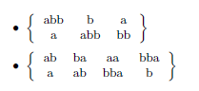**Problem 4.** Solve the following instances of PCP.

Combo: **1,3,1,1,3,2,2** -> abbaabbabbabb == abbaabbabbabb

**Impossible!** Only possible ending pair is set 3, but second to last letters don’t match.

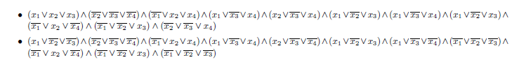**Problem 5.** Solve the following instances of SAT.

1. **Combination : $x_{1}:F x_{2}:F x_{3}:T x_{4}:T$**
2. **Combination : ${ x}_{1}:F x_{2}:F x_{3}:F x_{4}:F …all have at least 1 compliment…$**